Factory
(Creational)

In Factory pattern, we create object without exposing the creation logic to the client and refer to newly created object using a common interface.

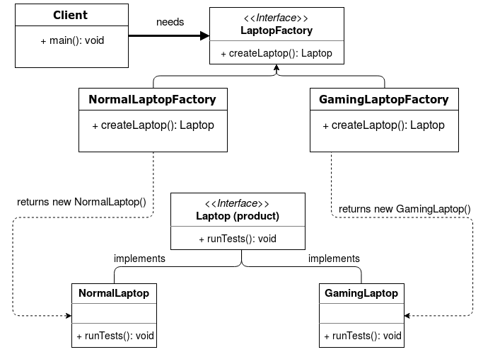

From the Agile Software Development, Principles, Patterns, and Practices book, the principle states:
- High-level modules should not depend on low-level modules. Both should depend on abstractions.
- Abstractions should not depend on details. Details should depend on abstractions.

Pros
- encapsulates object creation.
- decouples client code from object creation.
- isolates object creation logic, thus changes are made in only one place.

Cons
- added complexity – as with all patterns, overuse can hinder understanding of the system.

Step 1
public interface Laptop {
void runTests();
}

Step 2
public class NormalLaptop implements Laptop {

@Override
public void runTests() {
System.out.println("Running tests on a NormalLaptop...");
}
}

public class GamingLaptop implements Laptop {

@Override
public void runTests() {
System.out.println("Running tests on a GamingLaptop...");
}
}

Step 3
public interface LaptopFactory {
Laptop createLaptop();
}

Step 4
public class NormalLaptopFactory implements LaptopFactory {
public Laptop createLaptop() {
return new NormalLaptop();
}
}

public class GamingLaptopFactory implements LaptopFactory {
public Laptop createLaptop() {
return new GamingLaptop();
}
}

Step 5
public class Client {
public static void main(String[] args) {
LaptopFactory laptopFactory = new GamingLaptopFactory();

// Get a Laptop of type GamingLaptop.
Laptop myLaptop = laptopFactory.createLaptop();

// Use object.
myLaptop.runTests();
}
}

Step 6 (output)
Running tests on a GamingLaptop...

Summary
In conclusion, the three main ideas you have to remember are:
- The factory pattern encapsulates object creation.
- The factory pattern decouples client code from object creation.
- The factory pattern gives your object creation code more flexibility and testability.

Resources:
https://dragonprogrammer.com/design-patterns-java-factory-method-pattern/

